**The Greenova Pantry – Fresh Meal Kits (Story Board)**



The University of Technology, Jamaica,

**Faculty:** Faculty of Engineering and Computing,

**School:** School of Computing and Information Technology,

**Module:** Web Programming; CIT2011,

**Name:** Travis Davis,

**ID#:** 2401555

**Tutor:** Ms. C. Anuli

**Date of Class:** Wednesdays at 6:00 pm

**Table of Contents**

**Introduction** 3

**Home/Product** 3

**About Us** 4

**Login/Registration** 5

**Cart** 7

**Order Finalization** 9

**GitHub** 10

**Hosting** 11

**References** 12

# **Introduction**

TheGreenova Pantry is a business that sells pre-packaged meal kits for different dishes. Each kit contains pre-measured, locally sourced ingredients with easy-to-follow recipes, making it easier for the customers, to shop for their next meal.

Below is a story board outlining the functions of the website. The arrows control the flow of the sequences of clicks as the functions of the website are being explained. Please follow the flow of the arrows; each click will be expounded on.

# **Home/Product**

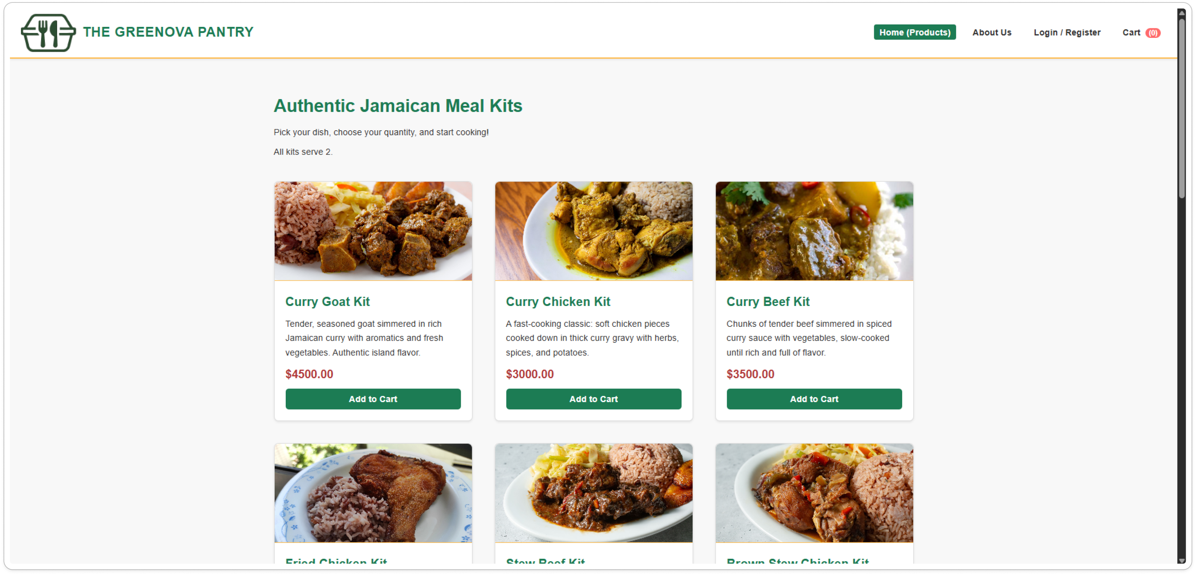

This is the home page/product page of the Greenova Pantry website. It is what welcomes you when you first load the website. This is where you add items that you want to purchase to your cart. The arrow points to the link that you can press anywhere on the website to get to the Home/Product page.

# **About Us**

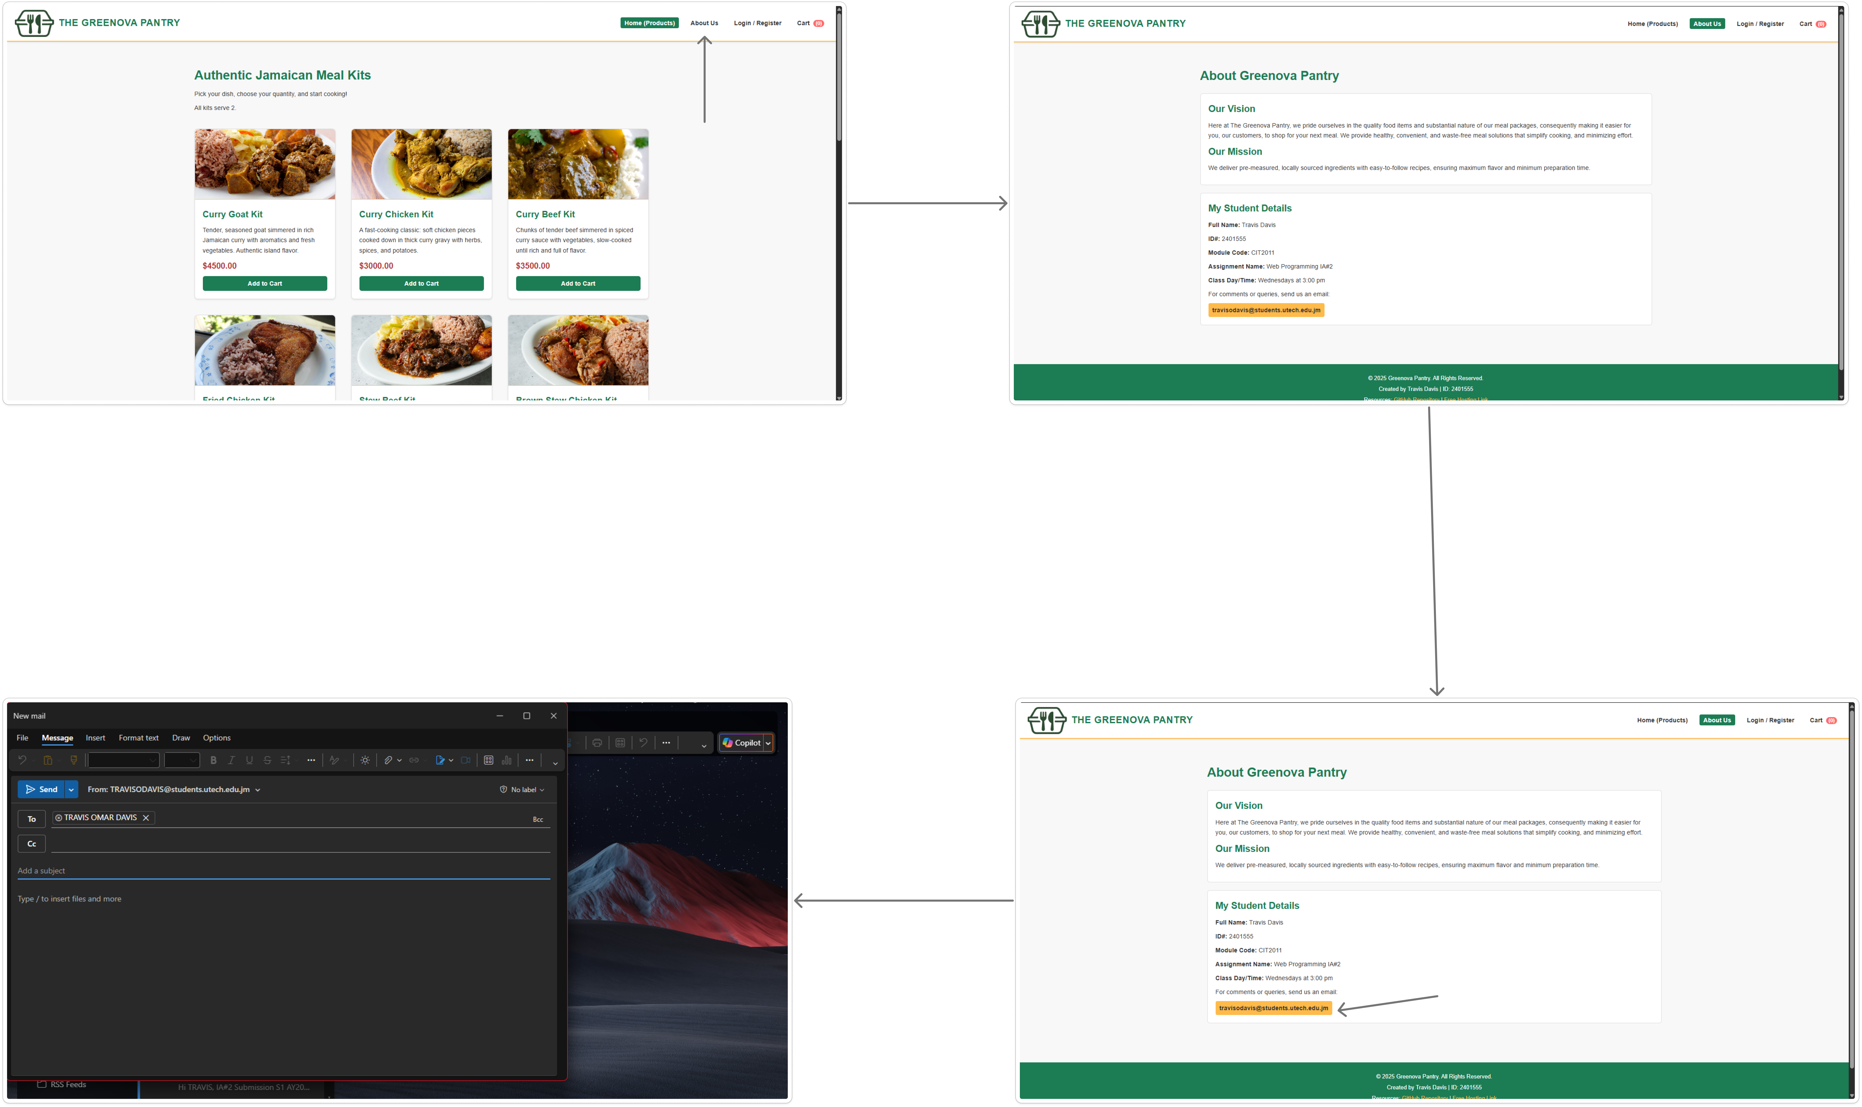

|  |  |
| --- | --- |
| 1. The arrow shows the link that you click to get to the “About Us” page. 2. The image below the Home/Product page shows the email dialogue box that comes up after clicking the yellow email button. | 1. The About Us page outlines our vision, and mission here at Greenova Pantry. It also includes the details of the creator of the website, as well as a means of contacting the creator. 2. That button is labelled by the email of the creator, [travisodavis@students.utech.edu.jm](mailto:travisodavis@students.utech.edu.jm). Clicking that will allow you to send an email to the author. |

# **Login/Registration**

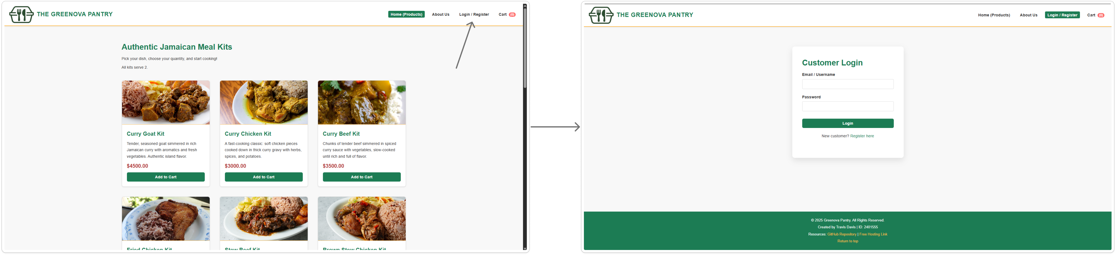

|  |  |
| --- | --- |
| The arrow indicates the button that takes the user to the login/register page. | This image shows the Login page. It is what you see after clicking the login/register button. |

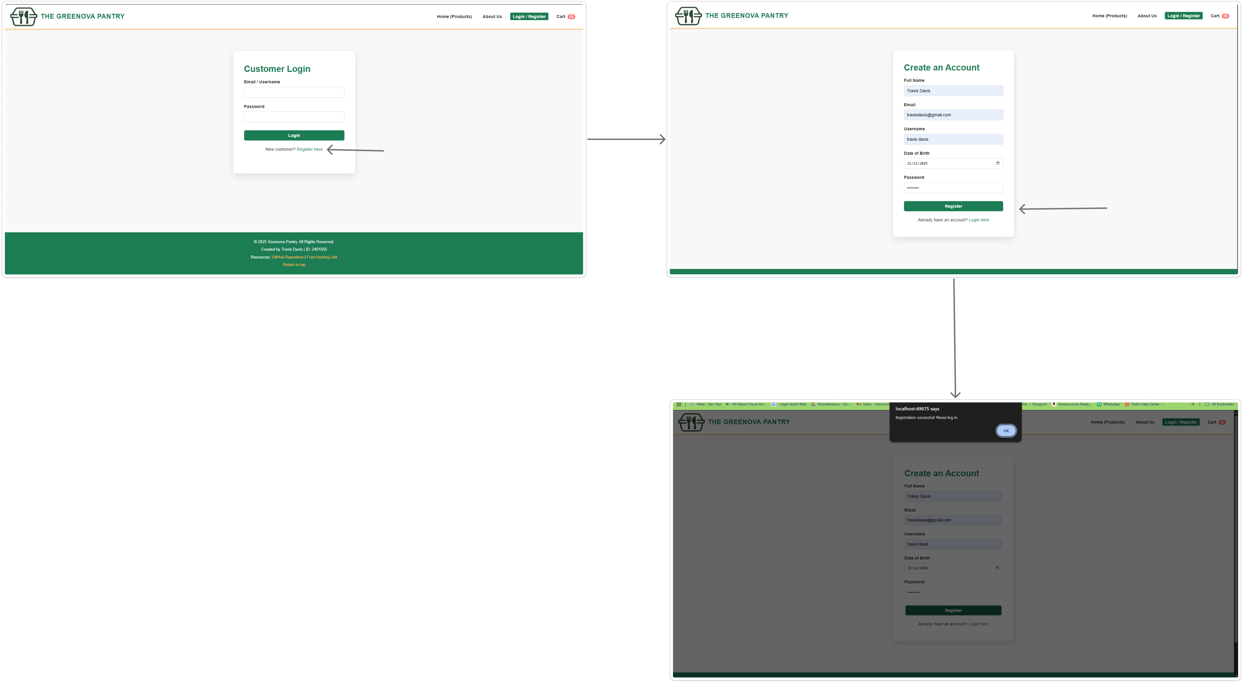

|  |  |
| --- | --- |
| 1. The arrow indicates the button that allows users to register an account on the Greenova Pantry website. | 1. Clicking the “Register Here” link takes you to the register page, which asks you for the necessary information required to create an account. 2. After filling out the form, and clicking the “Register” button, indicated by the arrow, you receive an alert indicating that you’ve successfully registered your account. |

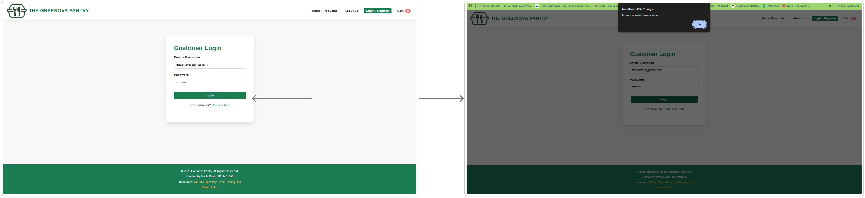

|  |  |
| --- | --- |
| The arrow indicates the log in button. This is what you click after filling out the login form with the relevant information. | After clicking the login button, you will receive an alert telling you that you’ve successfully logged into your account. |

# **Cart**

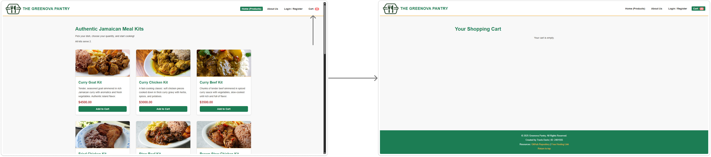

|  |  |
| --- | --- |
| The arrow indicates button you press to see your cart. | This is your cart when it is empty. |

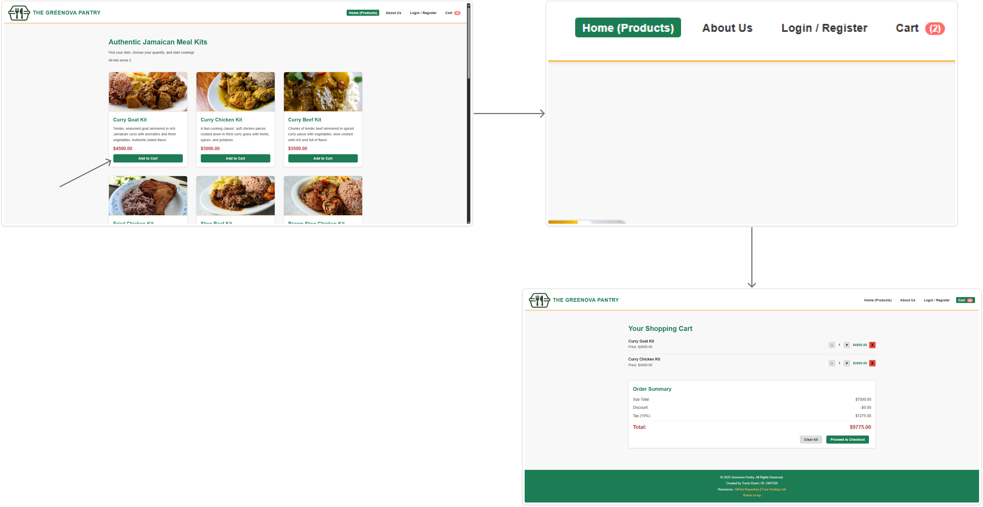

|  |  |
| --- | --- |
| 1. The arrow indicates the button the user clicks to add the items that they want to their cart. They can add any amount that they want. | 1. The number beside the “Cart” on the button indicates how many items are in the cart. It updates as you add items. 2. The Order summary page outlines the items you added to your cart, as well as the total for the items including only the tax, discount, and sub-total. |

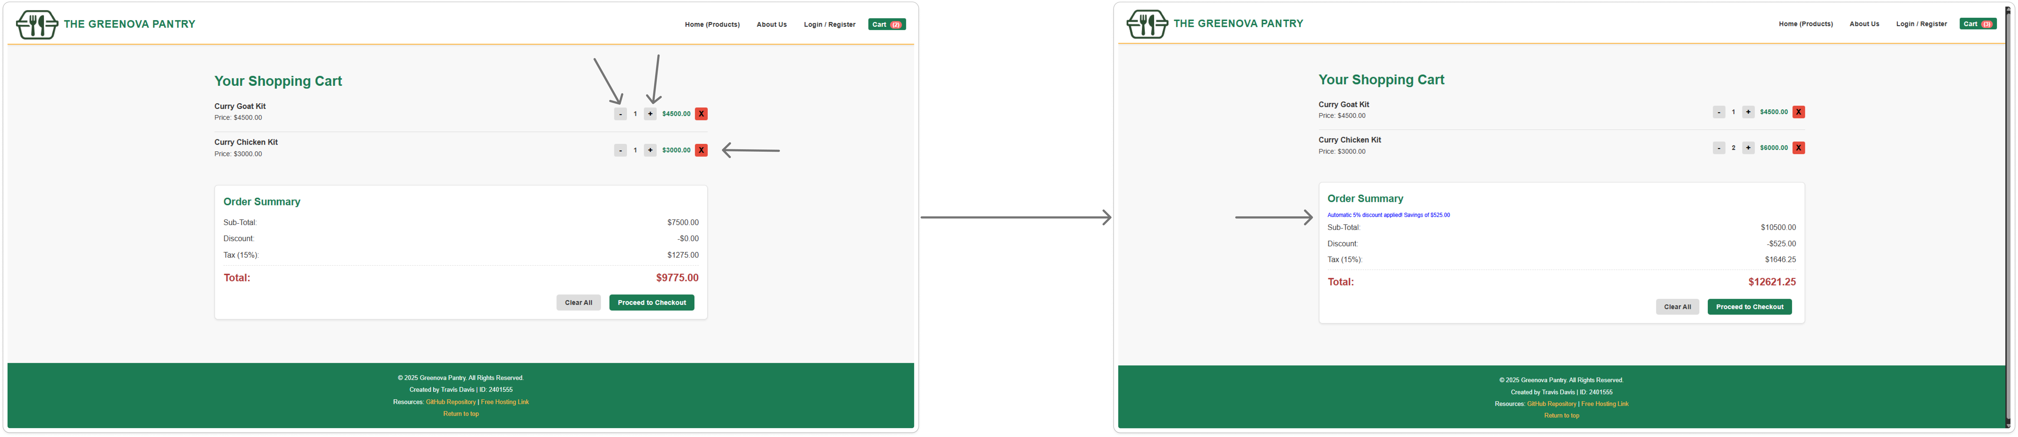

Remove Individual Item

Increase Quantity

Decrease Quantity

|  |  |
| --- | --- |
| The labelled arrows indicate the functions of each of the buttons. | This shows a 5% discount applied to the total cost of the items. The discount is automatically applied when the price is above $10,000.00. |

# **Order Finalization**

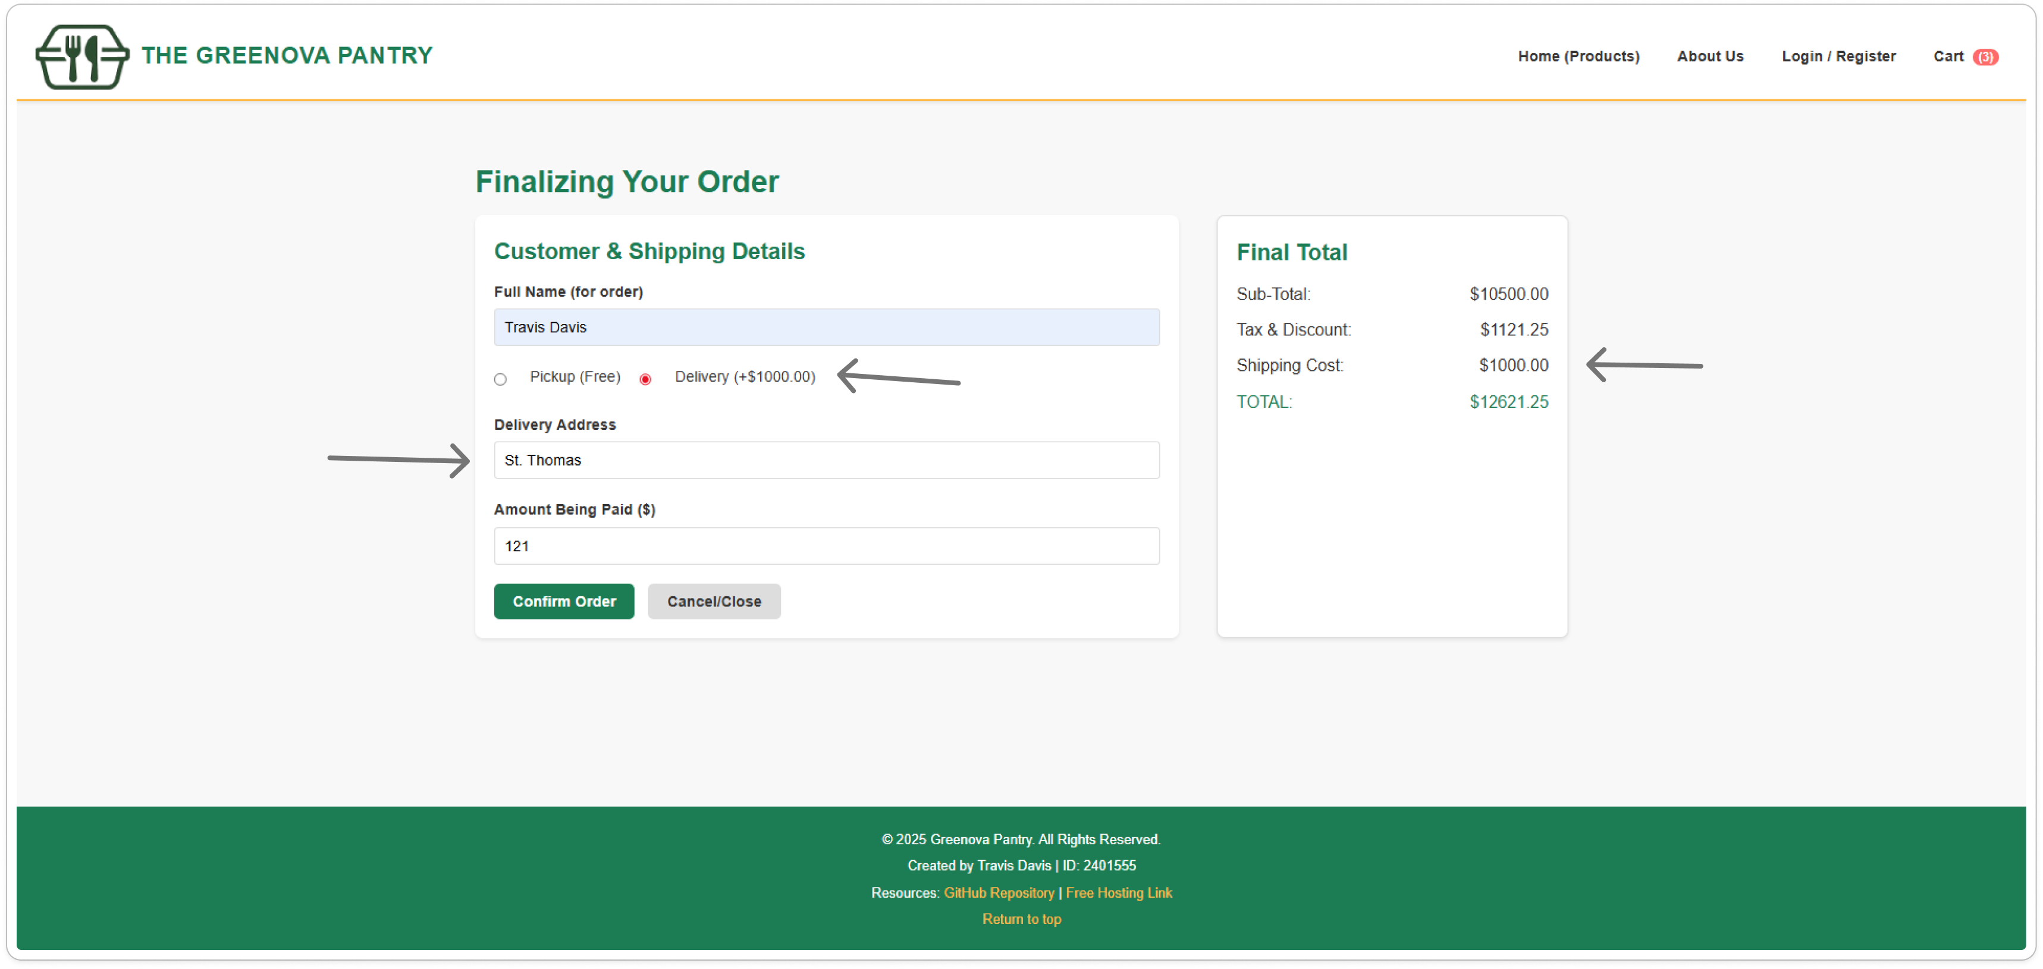

This page shows you the details about your order and allows you to select your delivery method. Having it delivered costs an extra $1000.00.

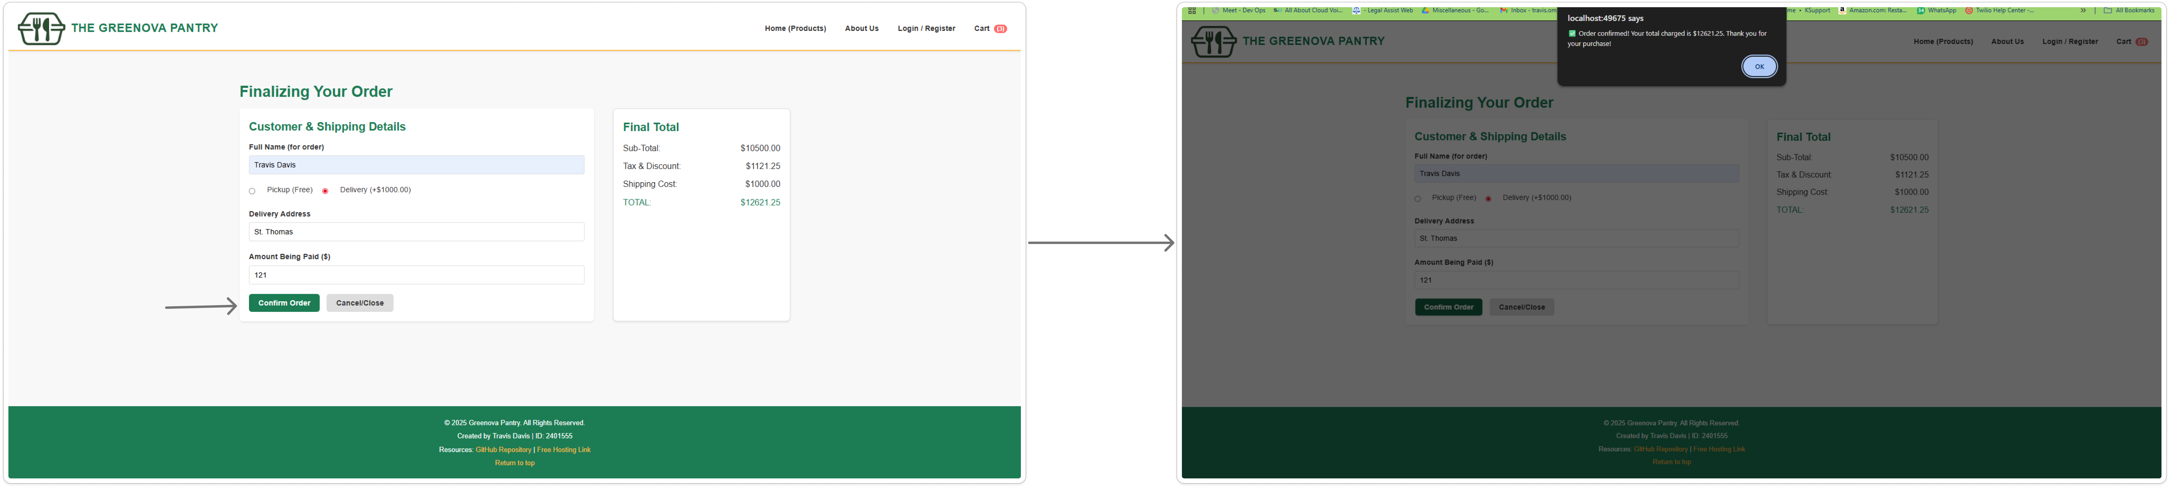

|  |  |
| --- | --- |
| The arrow indicates the button you press to confirm your order, after completing the form with the necessary information. | After confirming your order, you will receive an alert telling you that you’ve successfully completed your order. |

# **GitHub**

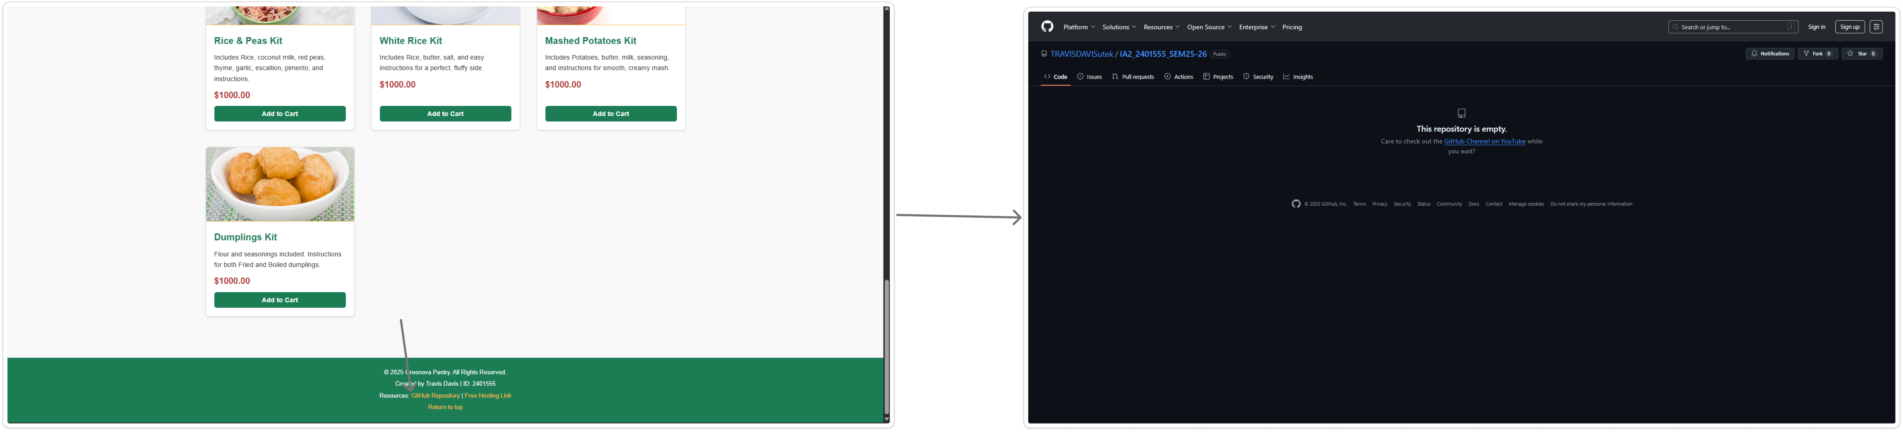

|  |  |
| --- | --- |
| The arrow points to the section of the footer of the webpage where the GitHub repository can be accessed. | <https://github.com/TRAVISDAVISutek/IA2_2401555_SEM25-26> |

# **Hosting**

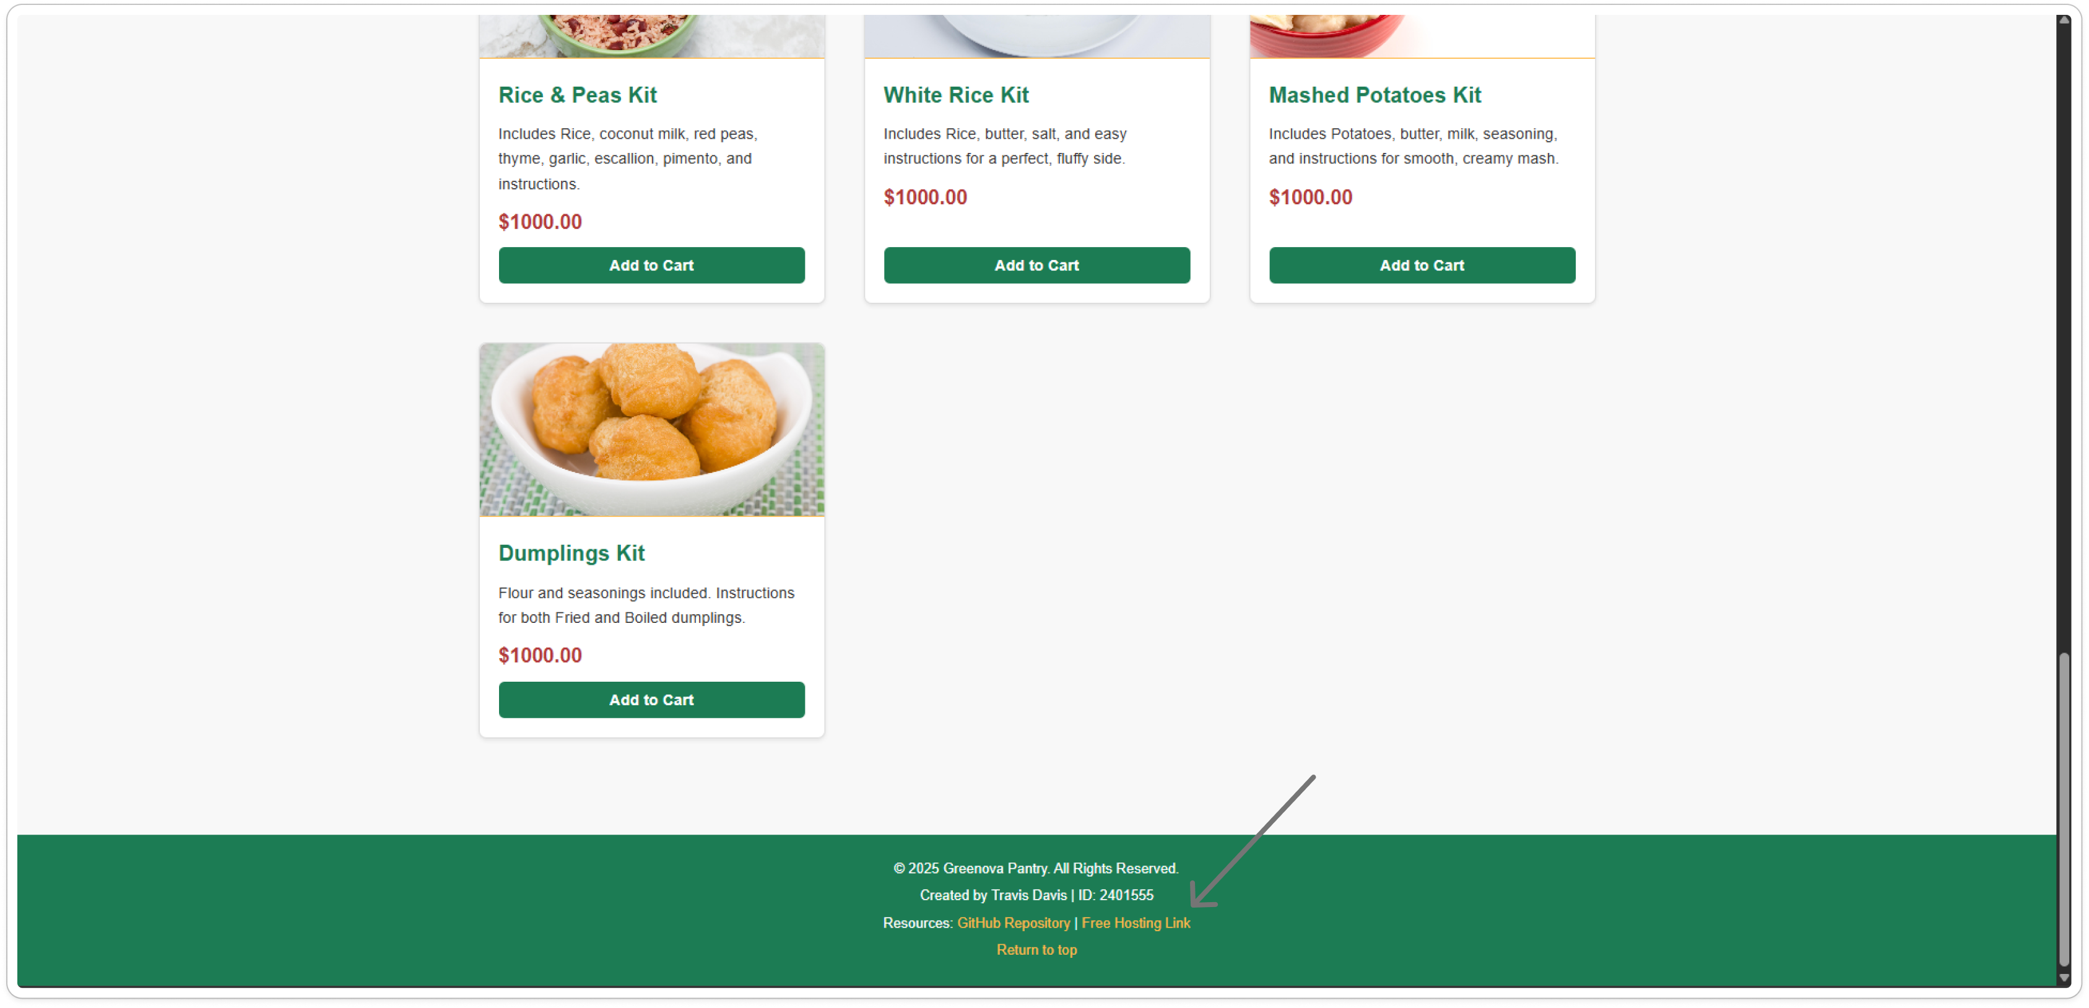

The arrow points to the section of the footer of the webpage where the hosting link can be accessed. <https://app.netlify.com/projects/2ia2401555travis/overview>

# **References**

*W3Schools.com*. (n.d.). W3Schools Online Web Tutorials. <https://www.w3schools.com/js/js_htmldom.asp>

*CSS grid layout*. (n.d.). MDN Web Docs. <https://developer.mozilla.org/en-US/docs/Web/CSS/Guides/Grid_layout>